**MINI-PROJECT REPORT ON**



**K_r**

**AN ONLINE SHOPPING AND GIFTING WEBSITE**



**Submitted in partial fulfillment of the requirement for the award of the degree of**

**BACHELOR OF TECHNOLOGY**

**IN**

**COMPUTER SCIENCE & ENGINEERING**

**Submitted by:**

**Student Name: Kajal Rawat** **University Roll No.:2118668**

*Under the Mentorship of*

**Mr. Akash Chauhan**

Assistant Professor



**DEPARTMENT OF COMPUTER SCIENCE AND ENGINEERING**

**GRAPHIC ERA HILL UNIVERSITY, DEHRADUN**



**CANDIDATE’S DECLARATION**

I hereby certify that the work which is being presented in the project report entitled **“K_r ”** in partial fulfillment of the requirements for the award of the Degree of Bachelor of Technology in Computer Science and Engineeringof the Graphic Era Hill University, Dehradun shall be carried out by myself under the mentorship of **Mr.Akash Chauhan, Assistant Professor**, Department of Computer Science and Engineering, Graphic Era Hill University, Dehradun.

**Name: Kajal Rawat University Roll no.: 2118668**

**Table of Contents**

|  |  |  |
| --- | --- | --- |
| **Chapter No.** | **Description** | **Page No.** |
| Chapter 1 | Introduction | 1 |
| Chapter 2 | Specification Required | 2 |
| Chapter 3 | Snapshots AND Sample Code of Project | 6 |
| Chapter 4 | Conclusion and Future Work | 17 |
| Chapter 5 | References | 18 |

**Chapter 1**

**INTRODUCTION**

* 1. **Introduction:**

K_r is a online shopping site for an existing shop, objective of the project is to provide the service of online shopping and home delivery to customers of a real shop. It helps them in buying the products of the shop anywhere through internet by using an devices like laptops and smart phones. This system can be implemented to any shop in the locality . If shops are providing an online portal where their customers can enjoy easy shopping from anywhere, the shops won’t be losing any more customers to the trending online shops such as flipcart or ebay. Since the application is available in the Smartphones/laptops/computers it is easily accessible and always available for the customers.

* 1. **Project Overview:**

The central concept of the application is to allow the customer to shop virtually using the Internet and allow customers to buy the items and articles of their desire, from the store.

* 1. **Object of the Project:**

This site can be implemented to any shop in the locality.The system recommends a facility to accept the orders 24x7 and a home deliveries which will provide customer a good user experience, saving their time .

* 1. **Problem Statement:**

As online shopping gaining popularity nowadays the regular shops are losing their customers to online brands. Customers have effortless shopping experience and saving time through shopping online. For competing with those online brands , If shops are providing an online portal where their customers can shop through internet and get the products at their doors it will increase the number of customers and help them grow their business.

**Chapter 2**

**SPECIFICATION REQUIREMENTS**

**2.1 Functional Requirements:**

* LOGIN

This feature used by the user to login into the site. A user must be login with his/her user name and password to the system after registration. If they are invalid, the user not allowed to access the confidential pages of the site.

* Username and password will be provided after user registration is confirmed.
* Password should be hidden from others while typing it in the field.
* When user login to the site cookies will be generated.

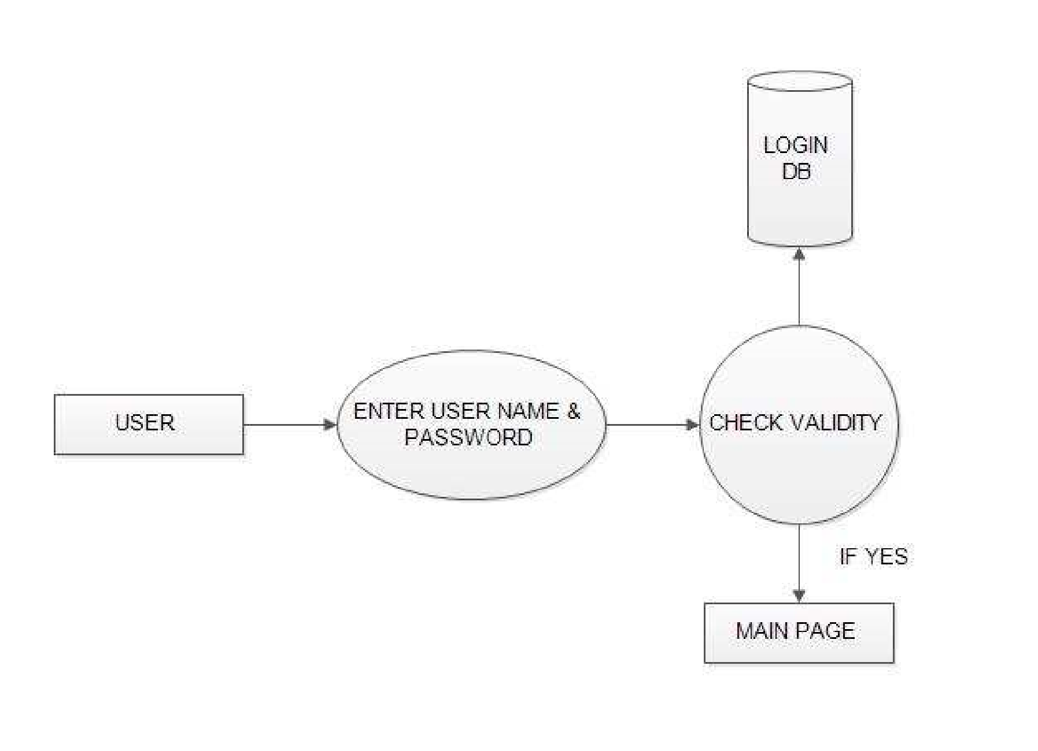

* REGISTERING NEW USER

A new user will have to register in the system by providing essential details in order to purchase products.

* System must be able to verify and validate information.
* Tokens and cookies will be generated on successful registration of new user.
* The password will be hased and than stored to provide security.
* MANAGE USER

The administrator can add user, delete user and view user.

* Adiminstarter can see user info stored in the database.
* User can be removed by the adiminsterter.
* User can be add by the adiminsterter.
* PRIVATE INFORMATIONS

The user can see private info only when it is login into the site otherwise it can only see the products details.

* User must be login before accessing informations.
* If the user are not login than it has to login first and than can have the access.
* SENDING EMAILS:

The user will be provided with a confirmation email when every they register or submit a query in the help center.

* User require to login into the site for asking for any query.
* If user sign in for newsletter.
* AUTHENTICATION OF USER:

The user will be authenticate using JWT tokens.

* When user login/register to the site a jwt token will be generated.
* The token will be stored in the cookies.
* The user will be given access to private information only if has a valid token.

**2.2 System Tools Required:**

The various system tools that have been used in developing both the front end and the back end of the project are :

* **FRONT-END:**

The front-end of a website is **the part that users interact with**. Everything that you see when you're navigating around the Internet, from fonts and colors to dropdown menus and sliders are a part of front-end.

HTML, CSS, JAVA SCRIPT are utilized to implement the frontend.

* HTML (Hyper Text Markup Language) :
* HTML is a syntax used to format a text document on the web.it consists of a series of elements, elements tell the browser how to display the content,elements label pieces of content such as "this is a heading", "this is a paragraph", "this is a link", etc.
* CSS (Cascading Style Sheets) :

CSS is a style sheet language used for describing the look and formatting of a document written in a markup language.

* JAVA SCRIPT :

JS is a dynamic computer programming language. It is most commonly used as part of web browsers, whose implementations allow client-side scripts to interact with the user, control the browser, communicate asynchronously, and alter the document content that is displayed.

* **BACK-END:**

The back end refers to **parts of a computer application or a program's code that allow it to operate and that cannot be accessed by a user**. Most data and operating syntax are stored and accessed in the back end of a computer system. Typically the code is comprised of one or more programming languages.

The Back-end is implemented using JS and Mongoos (which is used to design the databases) with following libraries and moduls.

* Node.js:

Node. js is an open-source, cross-platform JavaScript runtime environment and library for running web applications outside the client's browser. Node. js can be used on the frontend as well as the backend.

* Express.js :

It is the most popular backend framework for Node. js, and it is an extensive part of the JavaScript ecosystem. It is designed to build single-page, multi-page, and hybrid web applications, it has also become the standard for developing backend applications with Node.

* Express body-parser :

It is an npm library used to process data sent through an HTTP request body. It exposes four express middlewares for parsing text, JSON, url-encoded and raw data set through an HTTP request body. These middlewares are functions that process incoming requests before they reach the target controller.

* Nodemailer:

It is a Node. js module that allows you to send emails from your server with ease. Whether you want to communicate with your users or just notify yourself when something has gone wrong, one of the options for doing so is through mail.

* Bycrpt.js:

This module enables storing of passwords as hashed passwords instead of plaintext.

* JSON web token (JWT):

It is JSON Object which is used to securely transfer information over the web (between two parties). It can be used for an authentication system and can also be used for information exchange. The token is mainly composed of header, payload, signature. These three parts are separated by dots(.).

* Cookie-Parser:

It is a middleware which parses cookies attached to the client request object.

* Mongoose :

It is an Object Data Modeling (ODM) library for MongoDB and Node.js. .Mongoose allows users to conveniently create and manage data in MongoDB. While it is possible to manage data, define schemas, etc.

* MongoDB:

It is a document database used to build highly available and scalable internet applications. With its flexible schema approach, it's popular with development teams using able to move quickly and easily methodologies.

**Chapter 3**

**SNAPSHOT AND SAMPLE CODES OF PROJECT**

* **SAMPLE CODE**
* **HTML:**

For Navigation bar

<!DOCTYPE html>

<html lang="en">

  <head>

    <meta charset="utf-8">

    <meta name="viewpocontent="width=device-width">

    <title>Mini_Project</title>

    <link href="style.css" rel="stylesheet" type="text/css"/>

 <linkrel="stylesheet"href="https://use.fontawesome.com/releases/v5.15.4/css/all.css" >

  </head>

  <body>

    <section id="header">

      <div class="logo">

        <h1>K_r</h1>

      </div>

      <ul id="navbar">

        <li><a class="active" href="index.html">Home</a></li>

        <li><a href="#category">Category</a></li>

        <li><a href="#about">About</a></li>

        <li><a href="blog.html">Blog</a></li>

         <li><a href="/contact">Contact</a></li>

        <li id="user"><a href="login.html"><img  src=" "></a></li>

        <li id="cart"><a href="/cart"><img  src="" title='Cart'></a></li>

      </ul>

<a href="#" id="close"><img src=" "></a>

</ul>

<div id="mobile" style="gap:20px ;">

<a href="login.html"><img src="="></a>

<a href="/cart"><img src=""title='Cart'></a>

<i id="bar" class="fas fa-outdent"></i>

</div>

</section>

    </section>

* **CSS :**

For Navigation Bar

#navbar {

display: flex;

align-items: center;

justify-content: center;

}

/*to remove bullets and padding(spacing)-> from home categroy shop...*/

#navbar li {

list-style: none;

padding: 0 20px;

}

/*to remove underline and color text-> from home categroy shop...*/

#navbar li a {

text-decoration: none;

font-size: 20px;

font-weight: 550;

color: black;

transition: 0.3s;

/*for smooth transition during hover effect*/

}

/*for hover effect->home category shop...*/

#navbar li a:hover {

color: purple;

}

/*to highligth the current page in which we r*/

#navbar li a.active {

color: purple;

}

#mobile {

display: none;

align-items: center;

}

#close {

display: none;

}

@media (max-width:799px) {

#navbar {

display: initial;

flex-direction: column;

align-items: flex-start;

justify-content: flex-start;

position: fixed;

top: 0;

right: -300px;

height: 100vh;

width: 300px;

background: lavenderblush;

box-shadow: 0px 5px 15px lavenderblush;

padding: 80px 0 0 10px;

transition: 0.4 sec;

margin: 0;

}

#navbar.active {

right: 0px;

z-index: 1;

}

#navbar li {

margin-bottom: 25px;

}

#mobile {

display: flex;

align-items: center;

}

#mobile i {

padding-left: 10px;

}

#close {

display: initial;

position: absolute;

top: 30px;

left: 30px;

color: #222;

font-size: 24px;

}

}

* **JAVA SCRIPT:**

For Navigation bar

const bar = document.getElementById("bar");

const close = document.getElementById("close");

const nav = document.getElementById("navbar");

if (bar){

bar.addEventListener('click',() =>{

nav.classList.add('active');

})

}

if (close){

close.addEventListener('click',() =>{

nav.classList.remove('active');

})

}

* **For LOGIN :**

const account = new mongoose.Schema({

name: String,

email: String,

phone: {type: String,unique: false},

gender: String,

age: Number,

country: String,

address: String,

password: String,

repassword: String,

tokens: [{

t: { type: String required: true }

}]

});

const na = mongoose.model("account", account);

app.post("/login.html", async function (req, res) {

//post:to get the data back from the front end

const name = req.body.name

const user = await na.findOne({ name });

if (!user) {

console.log("user not registered !!!")

res.redirect("/login.html");

}

else if (bcrypt.compare("req.body.password", user.password)) {

console.log("password match")

const token = jwt.sign({

_id: user._id,

name: user.name

}, jwt_secret);

console.log(token);

res.cookie("jwt", token);

console.log(req.cookies.jwt);

res.redirect("/index1.html");

}

else {

res.redirect("/login.html");

}

});

* **SNAPSHOT OF PROJECT**
* HOME

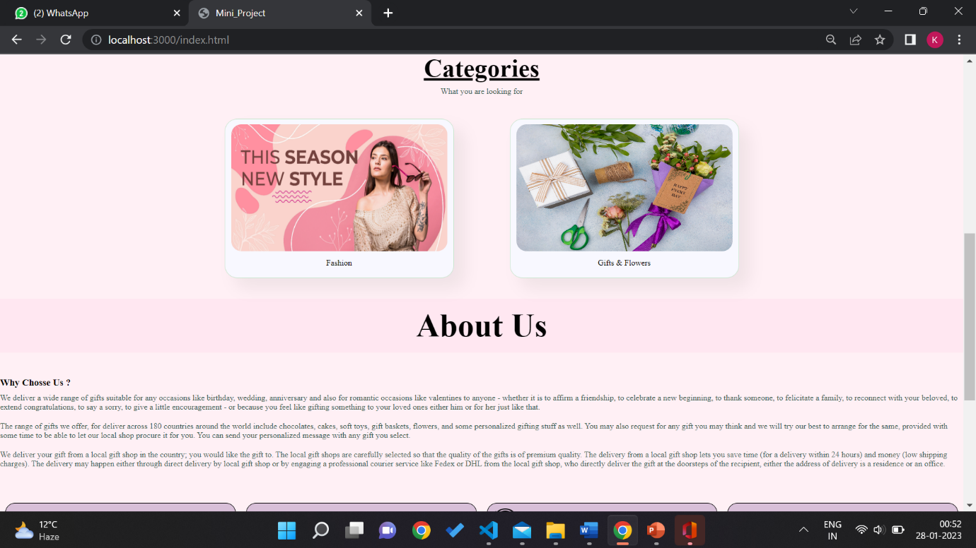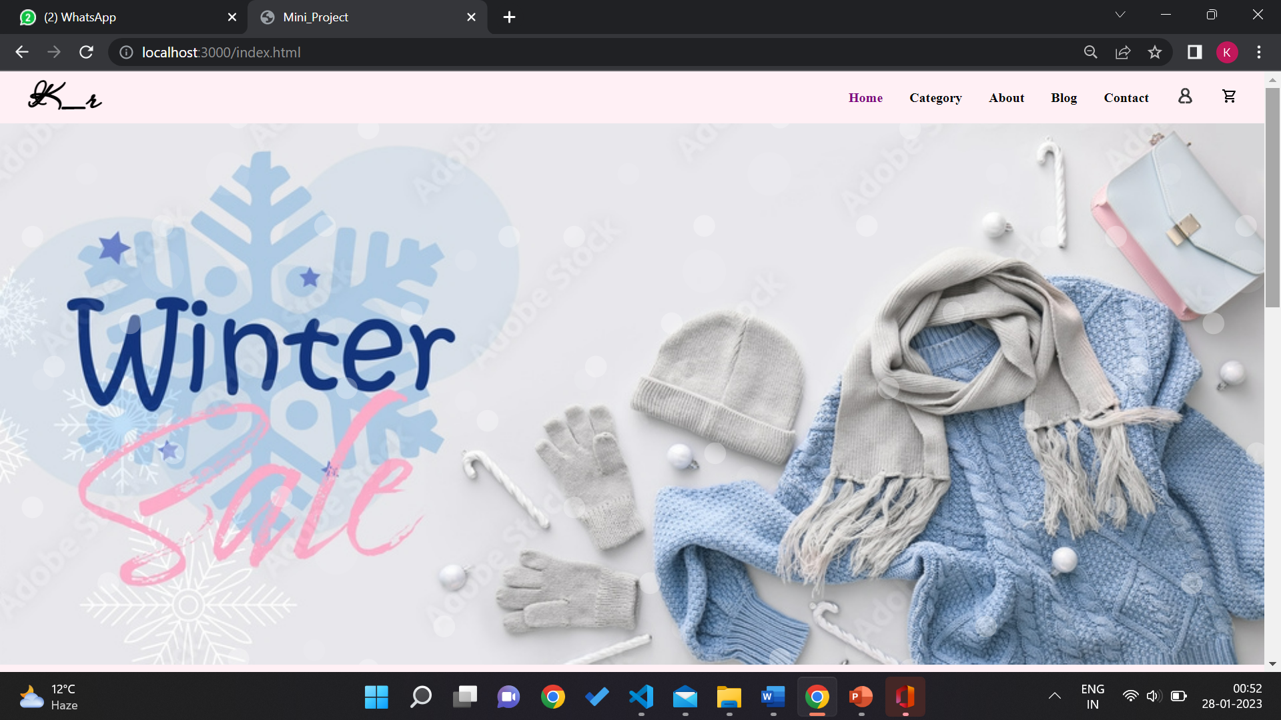

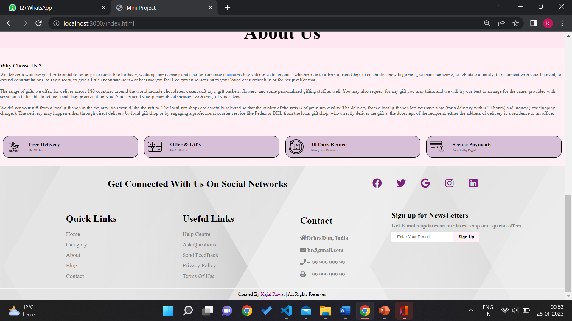

* LOGIN

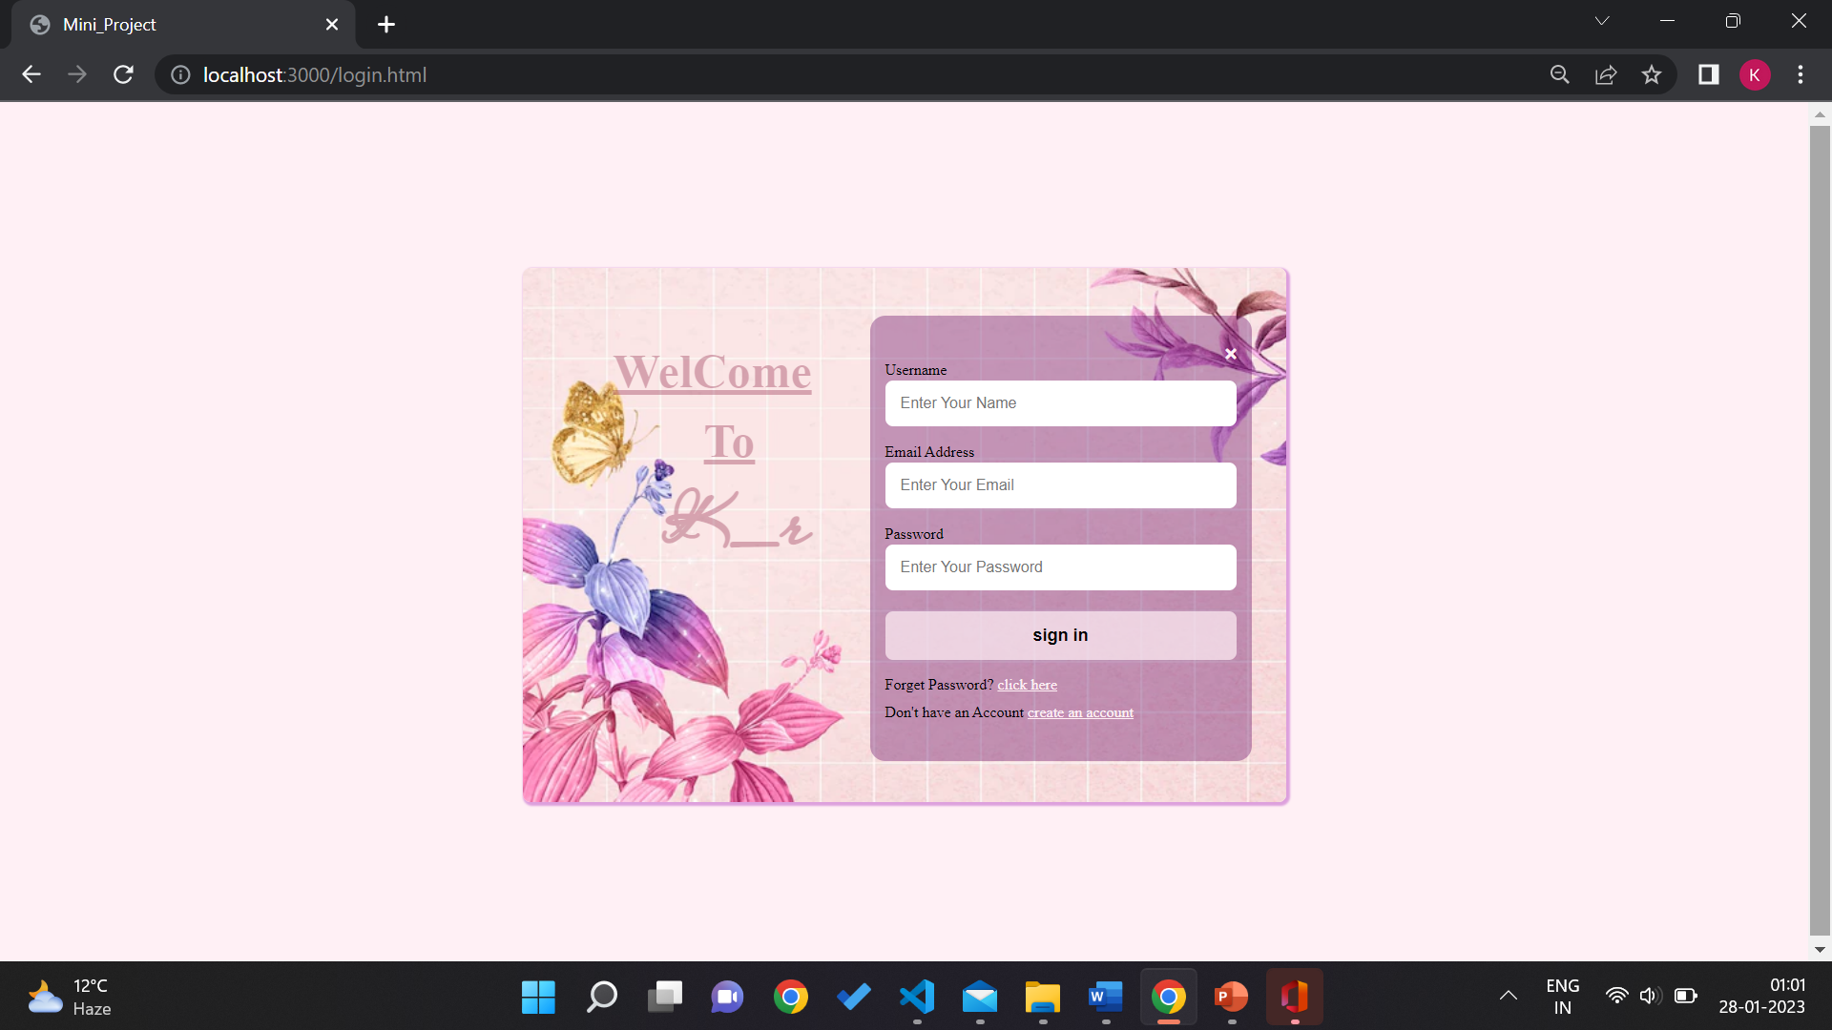

* REGISTRATION

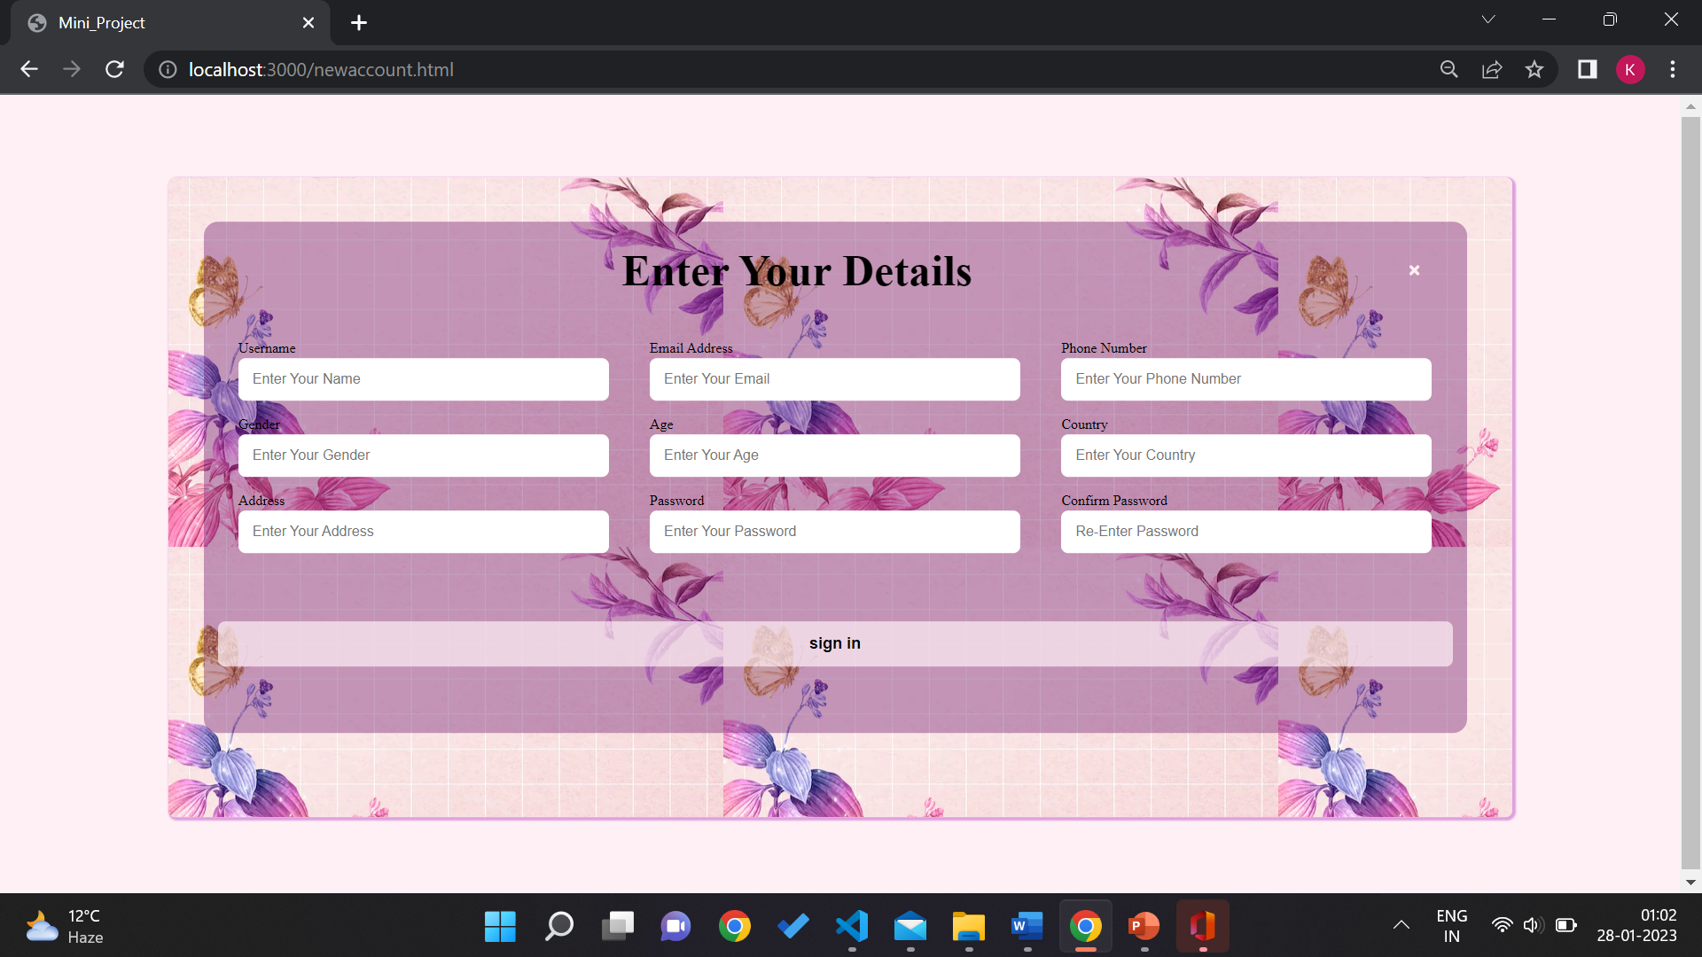

* FASHION

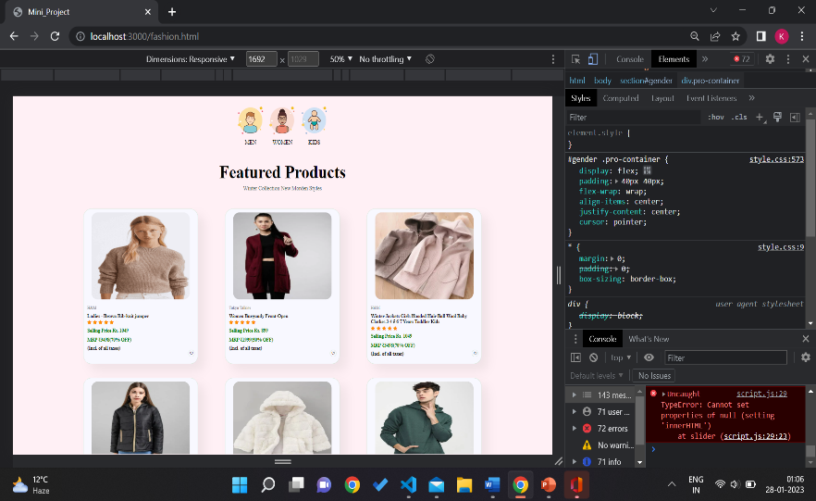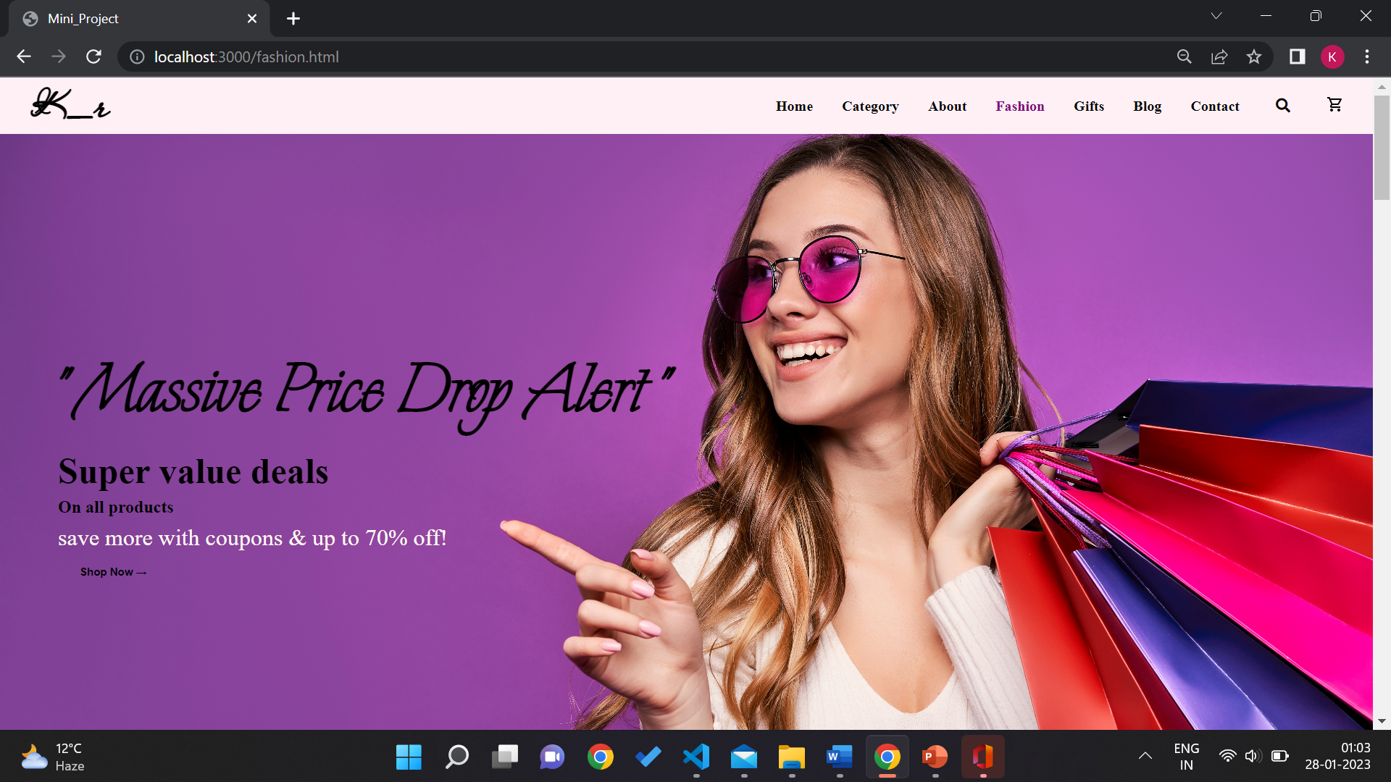

* GIFTING

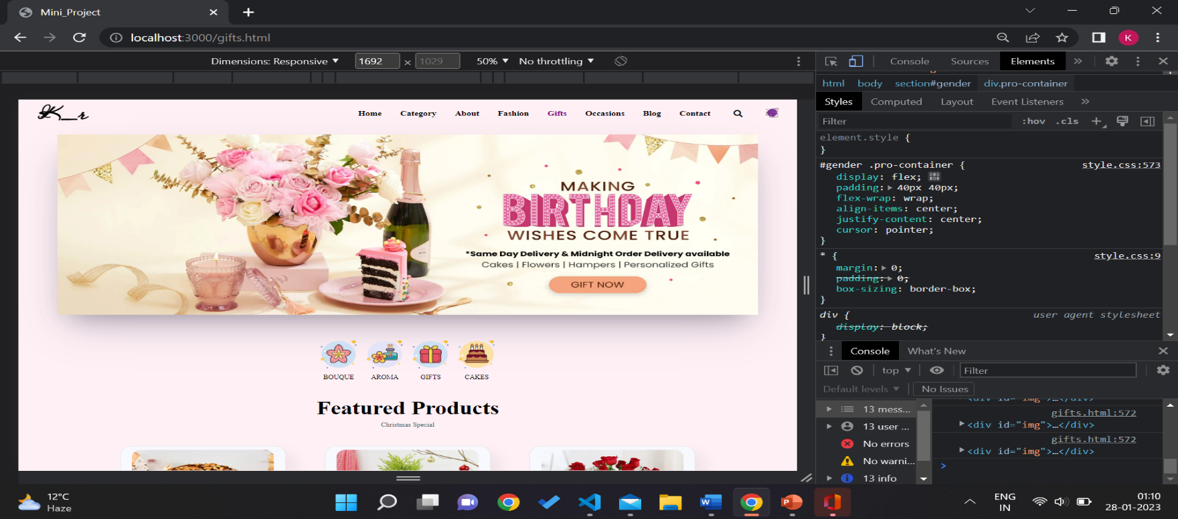

* PRODUCTS

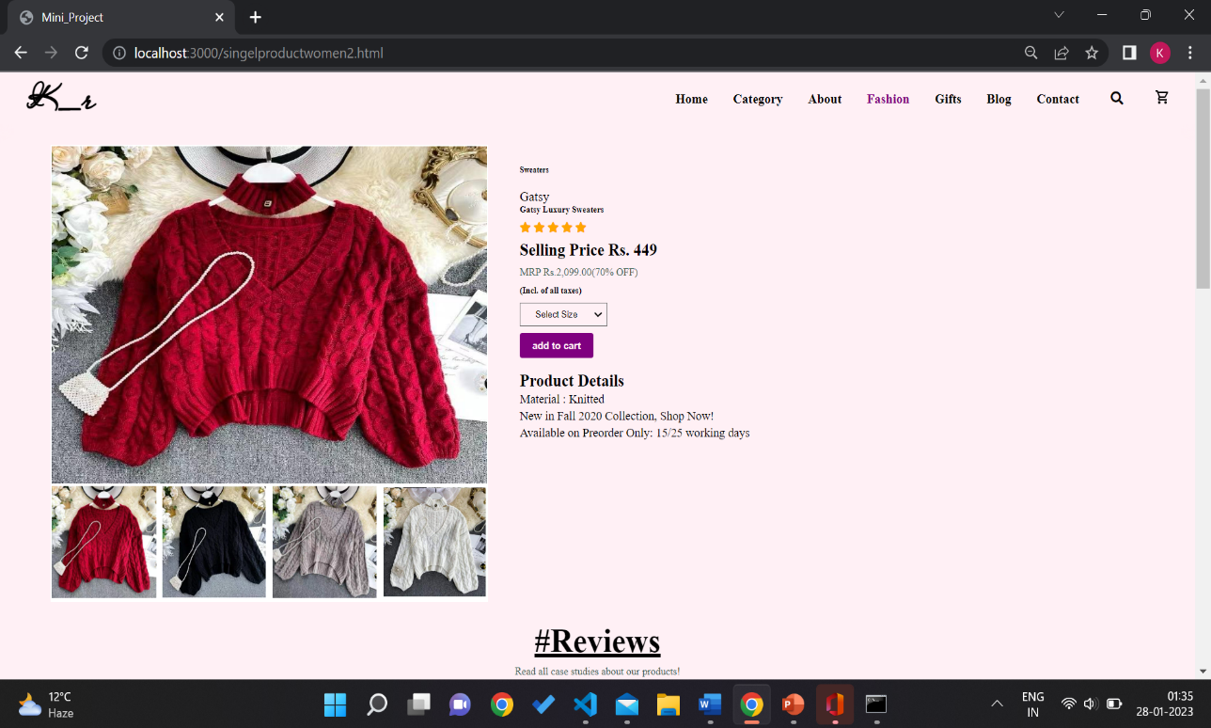

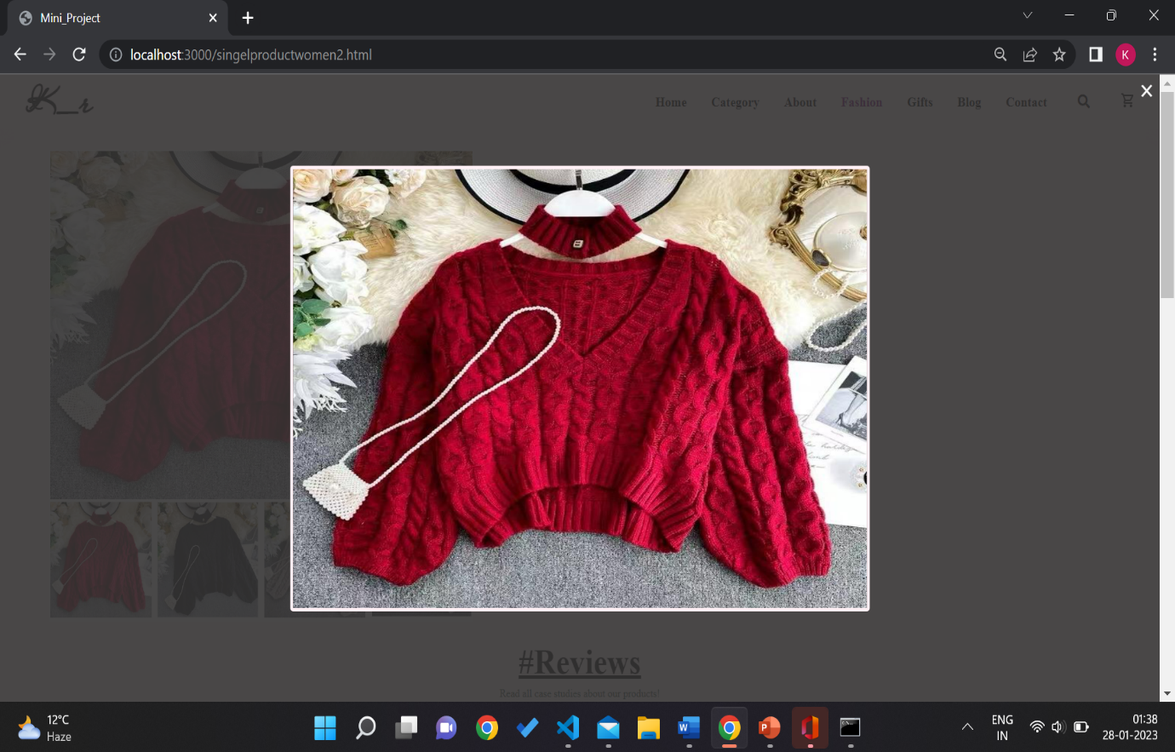

* CONTACT US

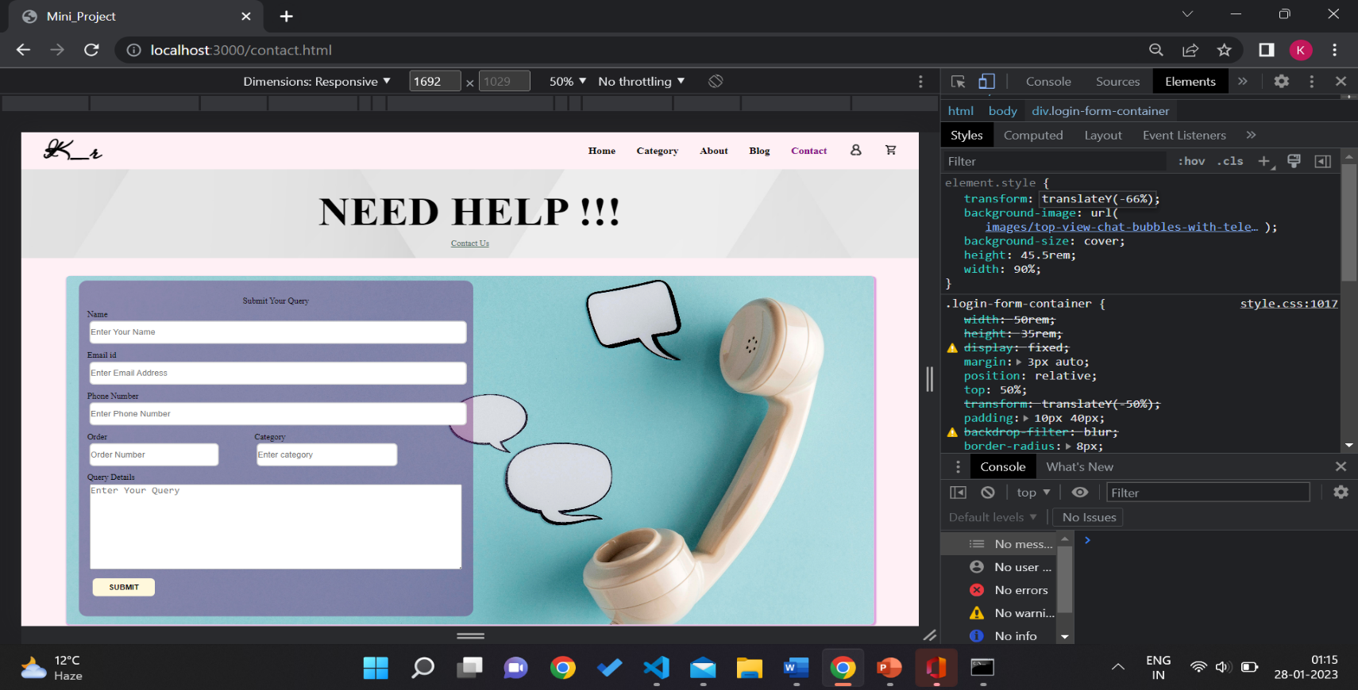

* BLOG

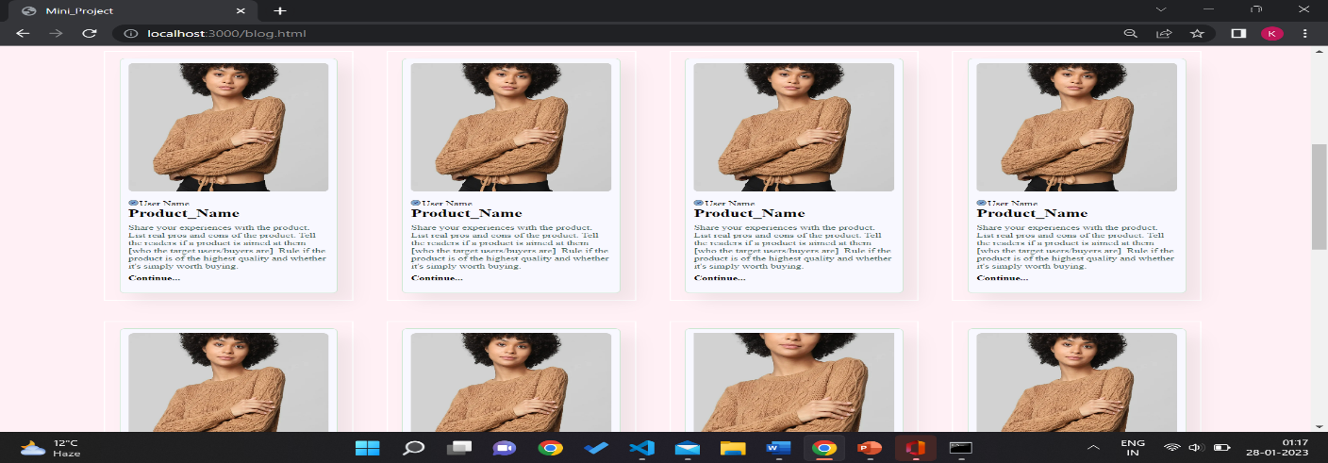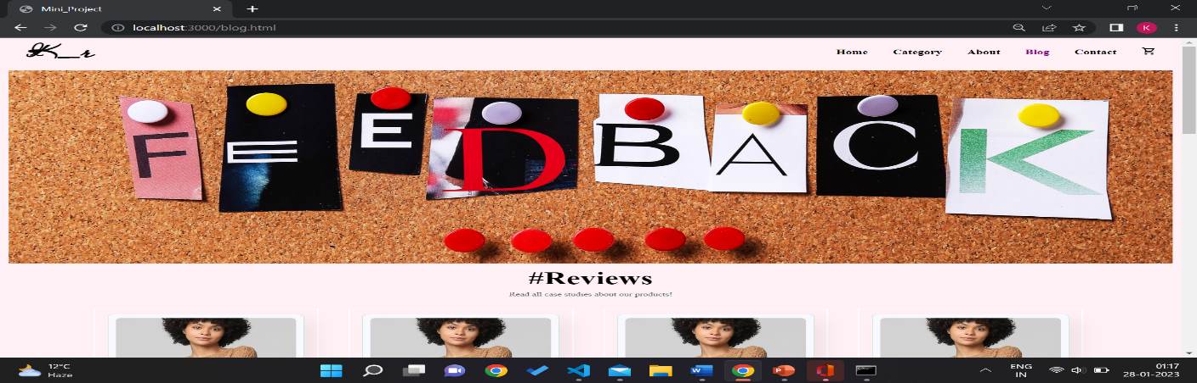

* CART

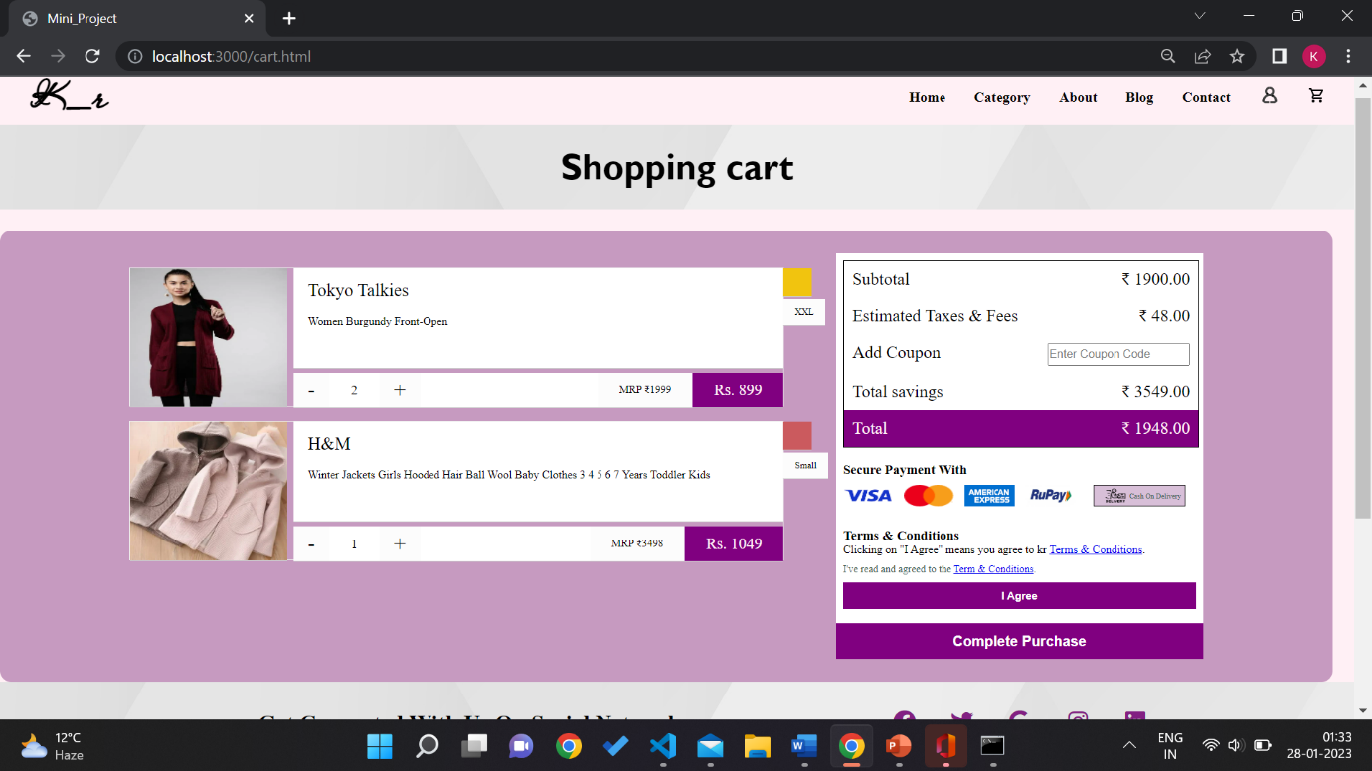

* 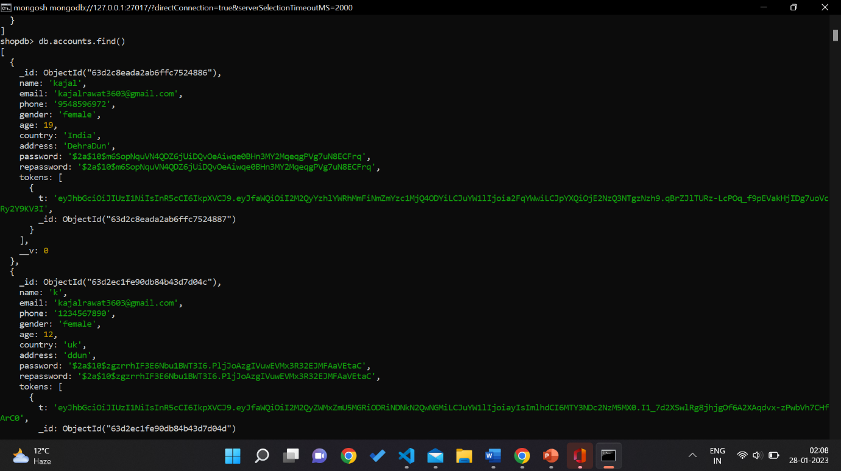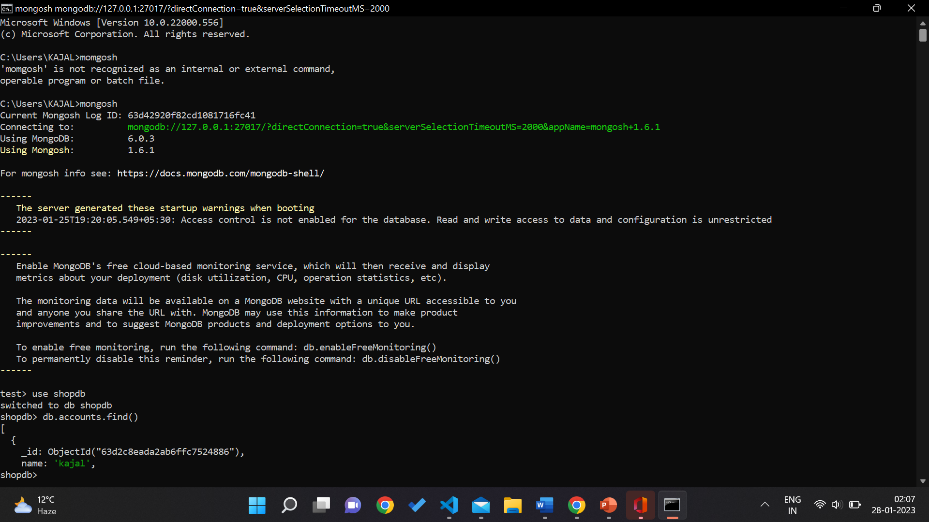DATABASE
* 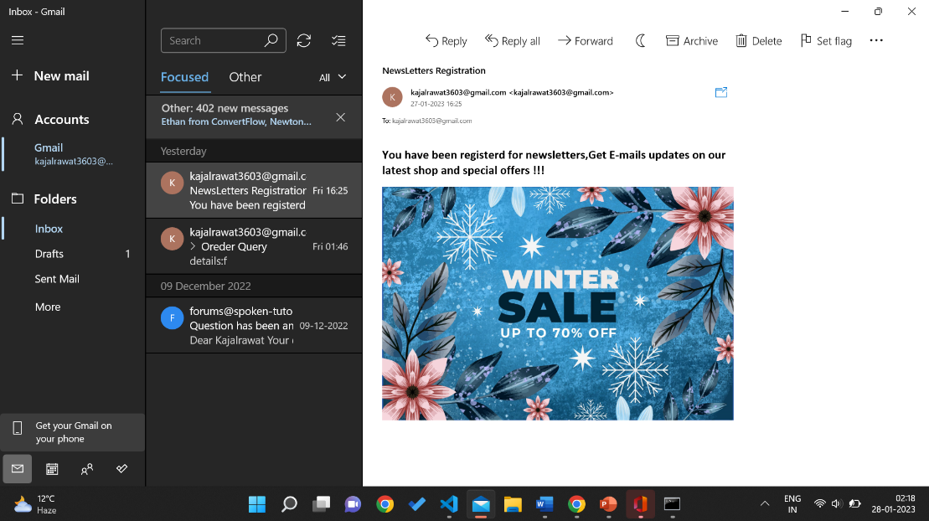Sent Email

**Chapter 4**

**CONCLUSIONS**

The purpose of this project was to develop a web application and an android application for purchasing items from a shop. This project helped me gaining valuable information and practical knowledge on several topics like designing web pages using html & css, usage of responsive templates, designing of android applications, and management of database using mongodb . The entire system is secured. Also the project helped us understanding about the development phases of a project and software development life cycle and learned how to test different features of a project.

* **FUTURE SCOPE :**

There is a scope for further development in our project to a great extend. A number of features can be added to this system in future like providing the owner control over products so that owner can maintain their products( add and remove products ),System may keep track of history of purchases of each customer and provide suggestions based on their history.

**Chapter 5**

**REFERENCES :**

* <http://www.w3schools.com/html/defualt.asp>
* <http://www.w3schools.com/css/default.asp>
* <https://www.w3schools.com/mongodb/>
* <https://nodemailer.com/about/>
* <https://www.mongodb.com/>
* <https://nodejs.org/en/>